Article Title
(Full title can be a maximum of 100 characters)
Author A¹, Author B², Author C*
^{1, 2} Affiliations
*E-mail: author c @ example.com

Abstract：
The abstract should be a single paragraph written in plain language that a general reader can understand. Do not include citations or undefined abbreviations in the abstract. Any abbreviations that appear in the title should be defined in the abstract. The length should be 200 words and not exceed 250 words, to include:
- An opening sentence that states the question/problem addressed by the research AND
- Enough background content to give context to the study AND
- A brief statement of primary results AND
- A short concluding sentence.

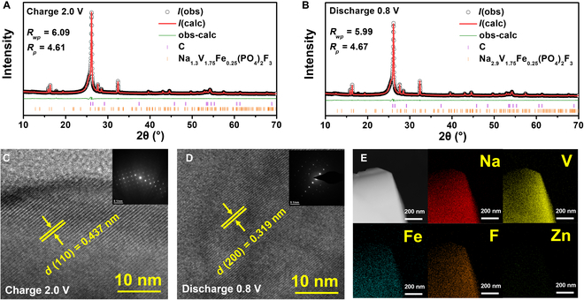
Fig. 1. X-ray Rietveld refinement profiles collected on the NVFePF cathode at (A) charging and (B) discharging states. High-resolution TEM images recorded at (C) charging and (D) discharging states. (E) EDX mapping in TEM mode at discharging state.

Acknowledgements
Funding: This work was supported by the National Basic Research Program of China (grant No. ××).

References
1. Li, H.; Bi, X.; Bai, Y.; Yuan, Y.; Shahbazian-Yassar, R.; Wu, C.; Wu, F.; Lu, J.; Amine, K. Adv. Mater. Interfaces 2016, 3, 1500740.
2. Bai, Y.; Zhao, L.; Wu, C.; Li, H.; Li, Y.; Wu, F. ACS Appl. Mater. Interfaces 2016, 8, 2857-2865.
3. Ni, Q.; Bai, Y.; Wu, F.; Wu, C. Adv. Sci. 2017, 4, 1600275.

